1. **Installing V4.0 board Driver**

Let’s install the driver of keyestudio V4.0 board. The USB-TTL chip on V4.0 board adopts CP2102 serial chip. The driver program of this chip is included in Arduino 1.8 version and above, which is convenient. Plug on USB port of board, the computer can recognize the hardware and automatically install the driver of CP2102.

If install unsuccessfully, or you intend to install manually, open the device manager of computer. Right click Computer----- Properties----- Device Manager

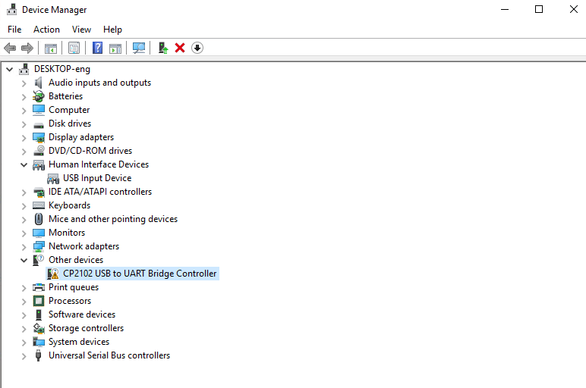

There is a yellow exclamation mark on the page, which implies installing unsuccessfully. Then we double click the hardware and update the driver.

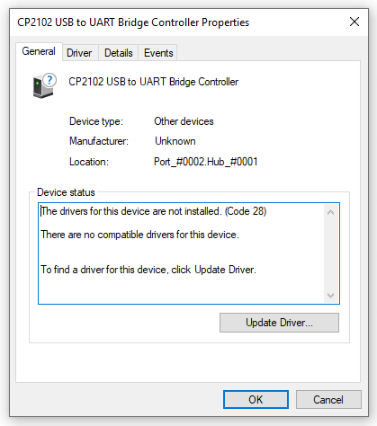

Click “OK” to enter the following page, click “browse my computer for updated driver software”, find out the installed or downloaded ARDUINO software. As shown below

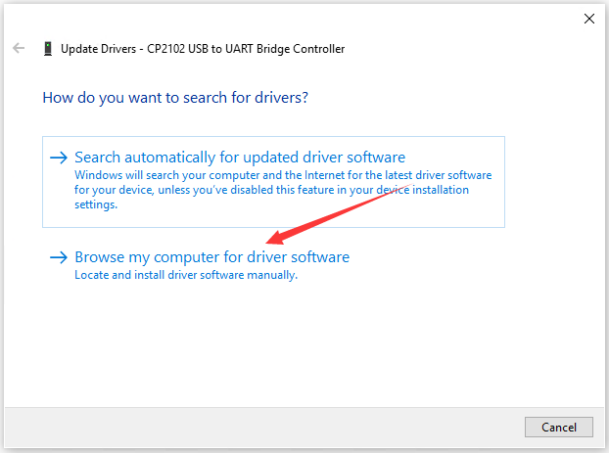

There is a DRIVERS folder in Arduino software installed package（）, open driver folder and you can see the driver of CP210X series chips.

We click “Browse”, then find out the driver folder, or you could enter “driver” to search in rectangular box, then click “next”, the driver will be installed successfully. (I place Arduino software folder on the desktop, you could follow my way)

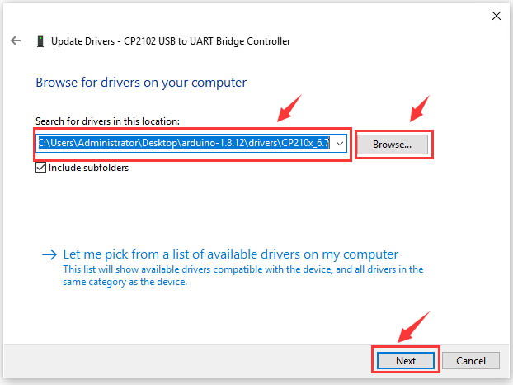

Open device manager, we will find the yellow exclamation mark disappear. The driver of CP2102 is installed successfully.

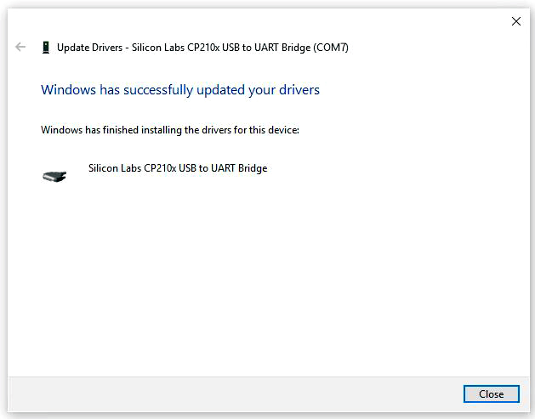

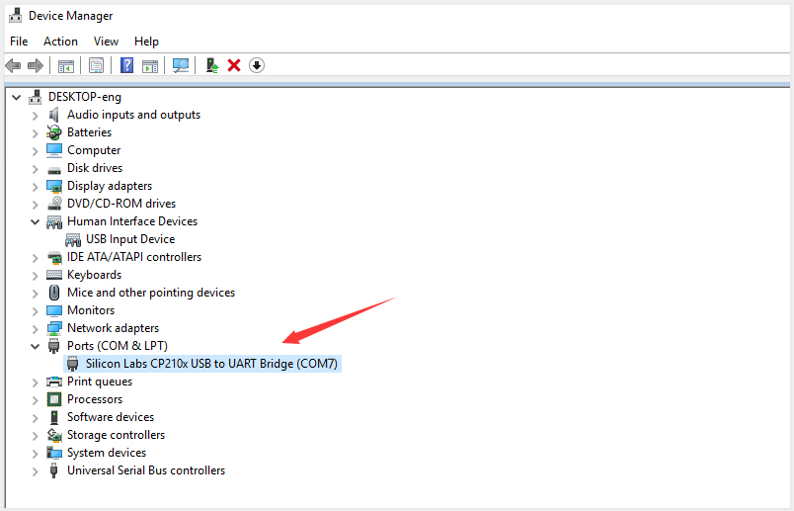

**The installation method of keyestudio MEGA 2560 board and V4.0 board is same**